Fast**National University of Computer & Emerging Sciences, Karachi  
Fall-2018Computer Science Department  
Midterm 1**

|  |  |  |
| --- | --- | --- |
| **Course Code: CS118** | **Course Name:Programming Fundamentals** | |
| **Instructor Name: M. Shahzad / Dr. Farooque / Shoaib Rauf / Tania Iram** | | |
| **Student Roll No:** | | **Section No:** |

Instructions:

* Return the question paper and make sure to keep it inside your answer sheet.
* Read each question completely before answering it. There are **3 questions and 1 page**.
* In case of any ambiguity, you may make assumption. But your assumption should not contradict any statement in the question paper.
* You are **not allowed to write** anything on the question paper (except your ID and group).

**Time**: 60 minutes. **Max Marks**: 15 Points

**Question 1:** Observe and try to understand the following programs. Write errors if there are any available or write outputs if the programs are fine. **[12 points = 6 *2 ]**

|  |  |
| --- | --- |
| (i)  void main()  {  int i = 2, k=1;  while (i< 5)  {  for (int j = 1;j <= i;++j)  do{  printf("i=%d,j=%d,k=%d\n",i,j,k);  k++;  }while(k<2);  ++i;  }  } | (ii)  void main()  {  int k;  for(int j = 1; j <= 5; ++j)  { k=0;  do  {  printf("#");  k++;  if(k==j-1)  { printf("-"); }  }while(k<j);  printf("\n");  }  } |
| (iii)  void main()  {      int i = 0;      switch (i)      {          case '0': printf("Hello");                  break;          case '1': printf("World");                  break;         default: printf("Hello World");      }  } | (iv)  void main( )  {  int i = 1, j = 1;  for( ; ; )  {  if(i>5)  break;  else  j+=i;  printf("\n %d",j);  i+=j;  }  } |
| (v)  void main()  {  int a, b, c;  a=7;  b=2;  c=b+a/b%2-1;  printf("%d",c);  } | (vi)  void main()  {      int i;      if (printf("0"))          i = 3;      else          i = 5;      printf("%d", i);  } |

**Question 2:** Akram is participating in Olympics and he is on a diet. His breakfast contains porridge or cornflakes. If he takes porridge on one day, he can only have cornflakes on the next. Write a program of breakfast planner for a month using control structures.

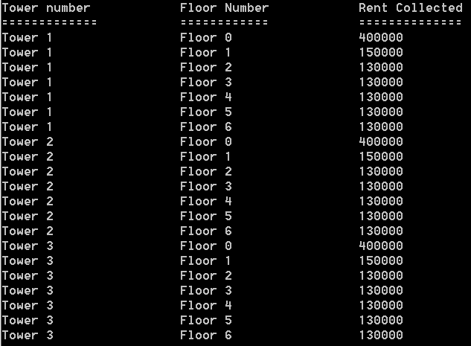**Question 3:** Regent Towers compound has 3 residential towers. Each building has 6 floors. Each floor has 4 apartments of which 2 are road facing. The ground floor is dedicated for 8 shops, each on a rent of 50,000 per month.

* First floor residents have to pay 40,000 monthly if they have a possession of road facing apartment, others have to pay 35,000 rupees.
* 2nd floor till 6th floor has a rent of 30,000, additional 5,000 is paid by owners of road facing flats.

Write a program to display the floor wise rent collected for all 3 buildings, expected output is as under

***BEST OF LUCK!***